**Answer 1 : Data Analysis Expressions (DAX)** is a recipe articulation language utilized in Analysis Services, Power BI, and Power Pivot in Excel. DAX equations incorporate capacities, administrators, and qualities to perform progressed estimations and inquiries on information in related tables and segments in plain information models.

**Answer 2:** **dashboards, reports, and datasets** - - are interconnected. The Related substance sheet is likewise a take off platform for making a move. From here you can do things like open a dashboard, open a report, produce experiences, break down the information in Excel, and that's just the beginning.

In the Power BI assistance, reports are based on datasets, report visuals are stuck to dashboards, and dashboard visuals connect back to reports. In any case, how do you have any idea which dashboards are facilitating visuals from your Marketing report? What's more how would you find those dashboards? Is your Procurement dashboard utilizing visuals from more than one dataset? Assuming this is the case, what are they named and how might you open and alter them? Is your HR dataset being utilized in any reports or dashboards whatsoever? Or then again, would it be able to be moved without bringing on any messed up joins Questions like these can be in every way replied on the Related substance sheet. Not exclusively does the sheet show the connected substance, it additionally permits you to make a move on the substance and effectively explore between the connected substance.

**Answer 4 :** With Power BI, you can associate with a large number of the administrations you use to maintain your business, like Salesforce, Microsoft Dynamics, and Google Analytics. Power BI beginnings by utilizing your certifications to interface with the assistance. It makes a Power BI work area with a dashboard and a bunch of Power BI reports that consequently show your information and give visual experiences about your business.

After you introduce the application, you can see the dashboard and reports in the application and the work area in the Power BI help (https://app.powerbi.com). You can likewise see them in the Power BI versatile applications. In the work area, you can alter the dashboard and reports to address the issues of your association, and afterward disperse them to your partners as an application.

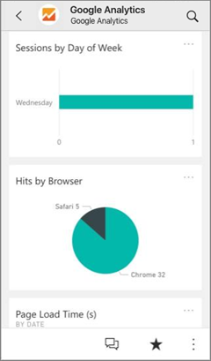

**GET STARTED**

1. Select Apps in the nav sheet > select Get applications in the upper-right corner.

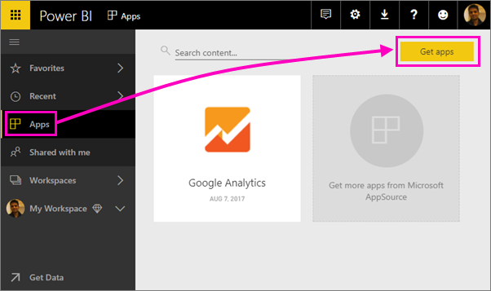

1. In AppSource, select the Apps tab, and quest for the help you need.

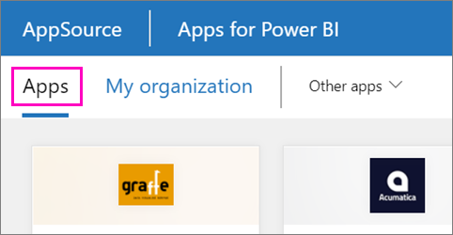

**Alter the dashboard and reports**

1. At the point when the import is finished, the new application shows up on the Apps page.

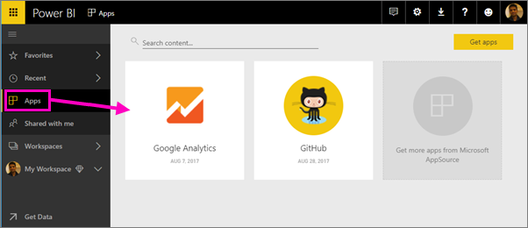

1. Select Apps in the nav sheet > select the application.

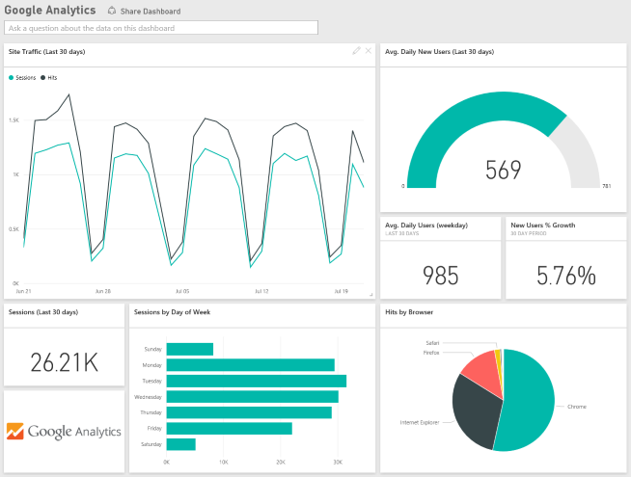

1. You can pose an inquiry by composing in the Q&A box, or snap a tile to open the hidden report.

**Answer 5:** steps to import file to Power BI:

* In Power BI, click Get Data in the lower left screen.
* Under Import or Connect to Data > Files, click Get.
* Click Local File.
* Pick which document to transfer and snap Open.
* Click Upload under Upload your Excel document to Power BI.
* The message "Your document has been transferred" ought to show up.

**Answer 6 :** The following are two modes for connecting with reports in the Power BI assistance: **Editing view** and **Reading view**. Assuming that you are a business client, then, at that point, you are bound to utilize Reading view to devour reports made by others. Editing view is utilized by report planners, who make the reports and offer them with you. Reading view is your method for investigating and interface with reports made by partners.